Test Report

Mobile Application AI Form Scriber

Milestone 4

SWEN 670

April 4, 2021

University of Maryland Global Campus

Version 1.0

Presented by: Sylvia Lopez, Bertina Lee, Brian Malott, Karim Mansour, Komi Noukafou, Sompon Boontho, Joselito Ocampo, Ermias Seyoum, Arnaud Tako, Alex Dattilio, Roy Gordon, Johnny Lockhart

Table of Contents

**Test Report** 4

**1. Introduction** 4

**1.1 Purpose** 4

**1.2 Application Overview** 4

**1.3 Testing Scope** 4

**1.4 Intended Audience** 4

**1.5 Technical Project Stakeholders** 5

**2. Overview of Test Results** 5

**2.1 Test Roles and Responsibilities** 5

**2.2 Overall Assessment** 5

**2.3 Impact of Test Environment** 5

**3. Test Summary** 6

**4. Automation Testing** 6

**4.1 Unit Testing** 6

**4.2 Integration Testing** 8

**4.3 End to End Testing** 12

**4.3.1 Usability** 12

**4.3.2 Performance Testing** 15

**Version History**

|  |  |  |  |
| --- | --- | --- | --- |
| **Date** | **Version** | **Author** | **Description** |
| 03/30/2021 | 1.0 | Arnaud Tako, Sompon Boontho | Initial Release |
|  |  |  |  |
|  |  |  |  |
|  |  |  |  |

# **Test Report**

# **1. Introduction**

Form Scriber is an Artificial Intelligence mobile application developed to allow service professionals to process a conversation between the end-user and their client. The conversation will be formatted to give the service professional (end-user) the option to view reports from their Google Drive. The mobile application will allow the end-user to view help documents that will consist of the User Guide explaining how to use the Form Scriber app. The application will integrate Google DialogFlow, providing a natural language agent using modern technology to create a functioning AI mobile application. The Form Scriber app was designed using Flutter SDK and the Dart programming language, developed in Android Studio. It is a cross-platform mobile application that was developed for Android and iOS mobile devices.

## **1.1 Purpose**

The purpose of this document is to provide details of all the automated tests that were done to include unit testing, integration testing, and end-to-end testing.

## **1.2 Application Overview**

Form Scriber is a dynamic mobile application that can be used to create customized form reports. A professional can create a form. After a form is created by the professional, the Form Scriberapp records the user and their client's conversation. The form is then automatically filled out, and a formal report is generated, which can be saved on the mobile device and printed as a physical document.

## **1.3 Testing Scope**

This Test Report scope includes testing of all the functionality within the From Scriber mobile application. This will ensure the requirements of the mobile app described in the Software Requirements Specification document are met. The testing will also report any identified bugs or a list of functions that are not working as expected. Automation testing is performed. This software test's primary tasks were focused on the automated unit testing, integration testing, and end-to-end testing of the mobile application.

## **1.4 Intended Audience**

This Test Report's intended audience is the product owner and the development team that includes project manager, developers, and testers who participated in developing the Form Scriber mobile application.

## **1.5 Technical Project Stakeholders**

**Table 1:** Technical Stakeholders

|  |  |  |
| --- | --- | --- |
| **Name** | **Role** | **Email Address** |
|  | Stakeholder |  |
| Sylvia Lopez-Willis | Project Manager | slopezwillis@student.umgc.edu |
|  | Business Analysts |  |
|  | Developer |  |
|  | Developer |  |
| Arnaud Tako | Test Engineer | takoarnaud@gmail.com |
| Sompon Boontho | Test Engineer | sboontho@student.umgc.edu |

# **2. Overview of Test Results**

## **2.1 Test Roles and Responsibilities**

The roles and responsibilities of the testing are given in the below table.

**Table 2:** Test Roles and Responsibilities

|  |  |  |
| --- | --- | --- |
| **Team Member Name** | **Role** | **Responsibility** |
| Arnaud Tako | Test Engineer | Unit and integration testing |
| Sompon Boontho | Test Engineer | End to end testing |

## **2.2 Overall Assessment**

All the tests performed on the From Scriber mobile application have passed, and all tests have been completed without errors or bugs. For the exception of a few warnings during the automated integration test, that will be explained further in the integration testing section. All the specified requirements are present, and all the corresponding functions are working as expected.

## **2.3 Impact of Test Environment**

The test environment did not impact the operational performance of the Form Scriber mobile application.

# **3. Test Summary**

This report summarizes the testing results carried out during Milestone 4 of the project.

**Table 3:** Test Summary

|  |  |  |
| --- | --- | --- |
| **Tests Executed** | **Tests Passed** | **Tests Failed** |
| 4 | 4 | 0 |

# **4. Automation Testing**

## **4.1 Unit Testing**

We have created a test file for every file in lib, including Arrange, Act, and Asset as shown in the below screenshot. In the terminal, one can run the file by using the command “flutter tests” or by just clicking run in file.

For the messages screen, we have implemented 2 unit test cases, where one is to check the response of the function in conversation.dart, and the other is for getting a response as “Empty” or not.

Similarly, we have implemented the body with default code for each file in the lib folder where adding any function/code in any one of the files in lib folder will require adding the respective code under act body in the test file.

We have run automated testing to test the application units. All of these automated unit tests have passed, and all the units are working as expected.

## **4.2 Integration Testing**

Integration testing was performed on the entire application to verify if Form Scriber worked based on the stakeholder requirements. To ensure functionality worked properly with the application and did not contain errors, critical scenarios were tested. The tables below show the Test Cases that were done and labeled with a Test ID.

Table 1 - Form Scriber: Using Help Feature

|  |  |
| --- | --- |
| Test ID | Test Case 1 |
| Title | Form Scriber: Using Help Feature |
| Expected Output | Tapping on the “Help” button on the home screen should lead to the help page. |
| Actual Output |  |
| Result | PASSED |

Table 2 - Form Scriber: Viewing Drawer Menu Items

|  |  |
| --- | --- |
| Test ID | Test Case 2 |
| Title | Form Scriber: Opening Drawer Menu Items |
| Expected Output | When taping on the hamburger icon, it should open the drawer. |
| Actual Output |  |
| Result | PASSED |

Table 3 - Form Scriber: Functionality of Drawer Item

|  |  |
| --- | --- |
| Test ID | Test Case 3 |
| Title | Form Scriber: Tapping on Home Drawer |
| Expected Output | Tapping on the home drawer menu item should lead to the homepage. |
| Actual Output |  |
| Result | PASSED |

Table 4 - Form Scriber: Beginning Conversation and Choosing Template

|  |  |
| --- | --- |
| Test ID | Test Case 4 |
| Title | Form Scriber: Begin Conversation |
| Expected Output | Tapping on Begin Conversation will lead to the template selection page. |
| Actual Output |  |
| Result | PASSED |

Table 5 - Form Scriber: Chat

|  |  |
| --- | --- |
| Test ID | Test Case 5 |
| Title | Form Scriber: Chat |
| Expected Output | After the selection of a template, users should be able to send messages. |
| Actual Output |  |
| Result | PASSED |

## **4.3 End to End Testing**

End-to-end testing of the Form Scriber mobile application is performed to test the entire mobile application. This will verify if the app functions as expected. End-to-end testing of the Form Scriber mobile app is focused on the following parameters:

* Usability
* Performance

End-to-end testing simulates the interactions between the user and the Form Scriber application. End-to-end testing will verify and validate that the system has provided all the functionality mentioned in the Software Requirements Specification (SRS). It will further confirm that the features are working as per the stakeholders' expectations and the users.

### **4.3.1 Usability**

Form Scriber can be successful because of its usability, making it easy to learn, user-friendly, and less time-consuming to complete tasks.

The Form Scriber mobile app has 11 features that need to be tested. For the end-to-end test, we are using the Firebase Test Lab with Robo test. Figure 1 shows the login page with a login and help button.

The user will need Google credentials to login into the system. This feature is straightforward to use and understand. The system is designed to be used by both experienced and novice users.

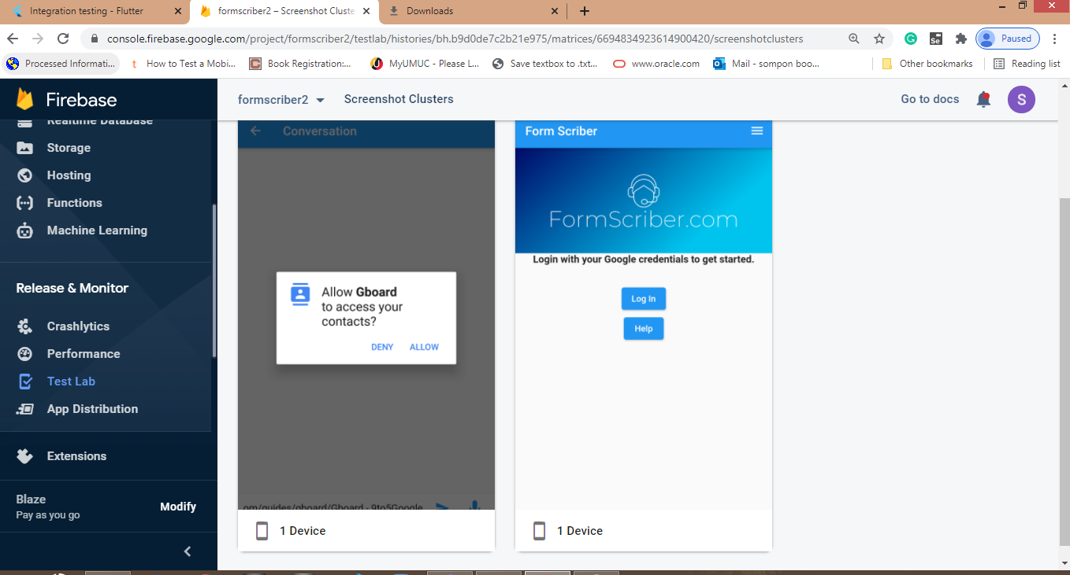

**Figure 1:** Login page end-to-end test

In the second test run, we combined six features to run as an end-to-end test, the test passed with two warnings. The warning is that it should be eleven features together, but we only had six features that were working at the time of testing. The results of this test are showing from figure 2 through figure 5. The other warning is related to the Non-SDK API usage issue, and it needs to be corrected to make these six features function as expected.

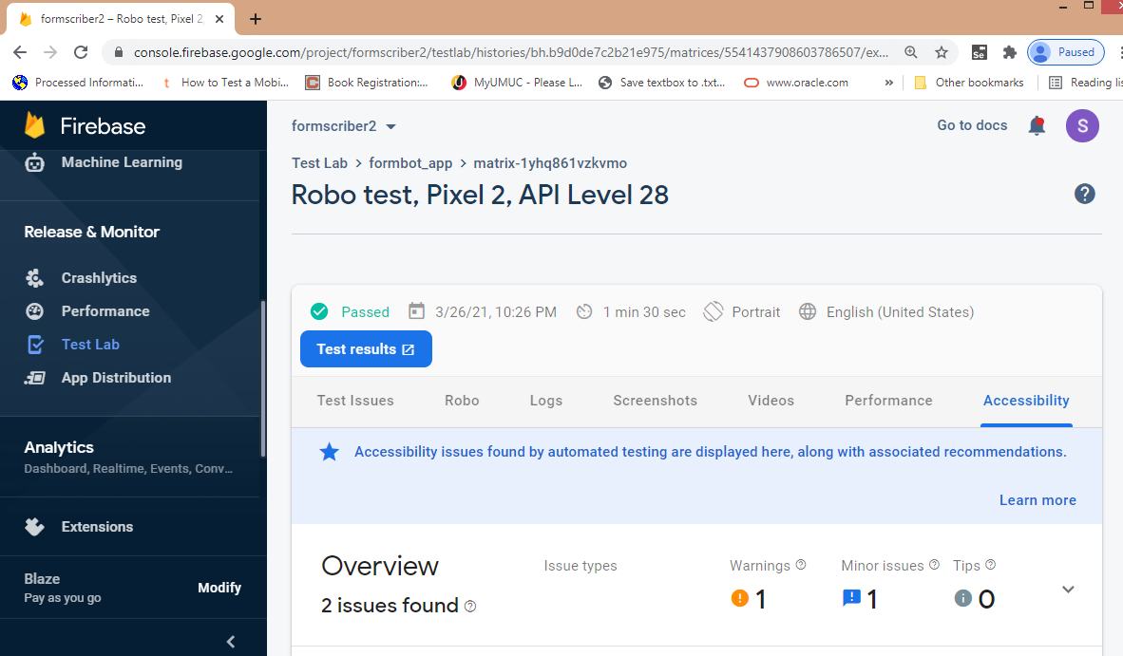

**Figure 2:** End-to-end test of six features combination

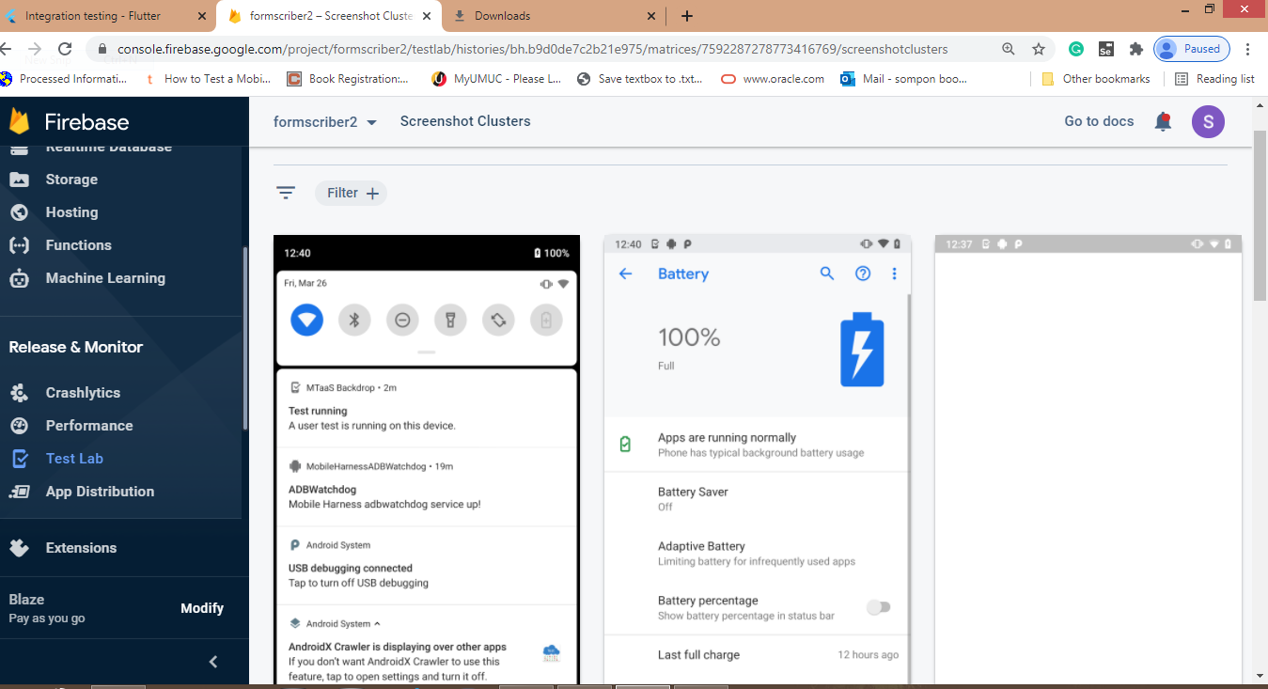

**Figure 3:** End-to-end test of six features combination - first half of the test run

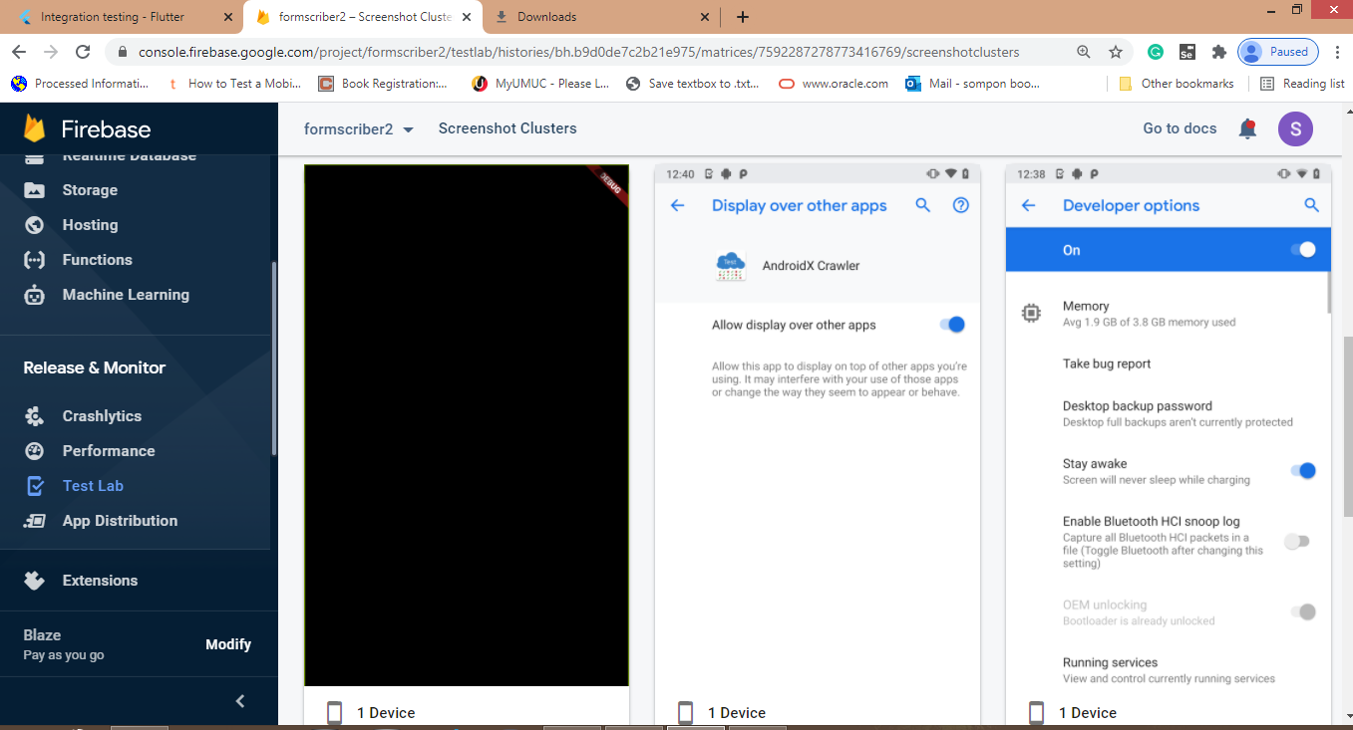

**Figure 4:** End-to-end test of six features combination – second half of the test run

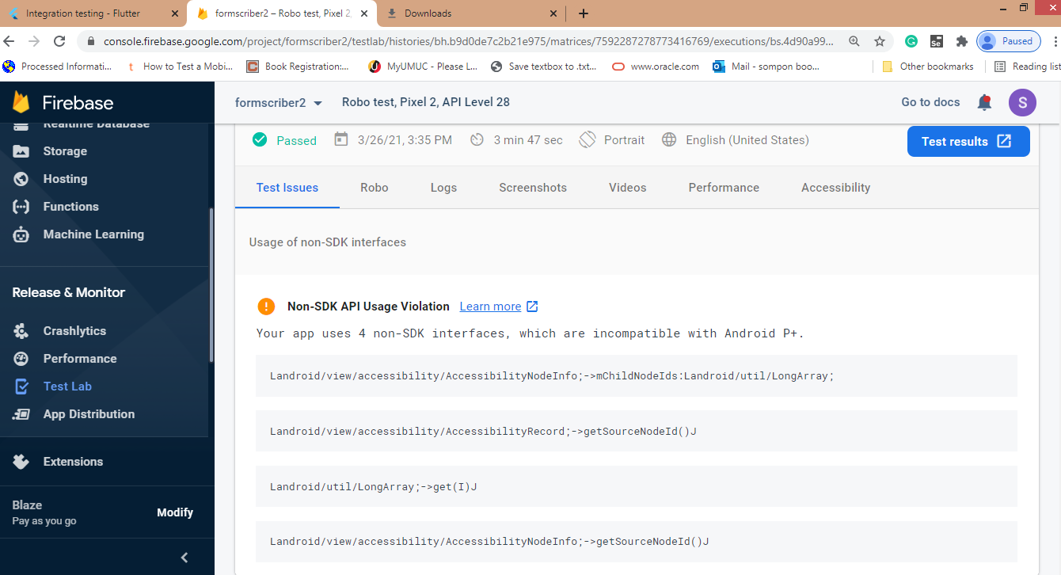

**Figure 5:** Test warnings report

The complete end-to-end test with full features will be performed in the next test when all the features will be available and ready to be integrated.

### **4.3.2 Performance Testing**

Firebase test lab also provides performance testing on the android device such as:

* Battery drainage and energy usage.
* Appropriate usage of the GPS and other features that drain battery.
* Network bandwidth usage.
* Memory usage.